'I1ie. Cmnmonwealtli of !Massacfwsetts
'13erqlure Countg 9lJ:ti,reme:nt System
29'1>unliam Mall
Pi !i\-6101201

'l'el. 413-499-1981 413-445-7990
October 12, 2023 To: Town Clerks
Berkshire Coun ty Retirement Advisory Board Annual Meeting Please join the meeting from your computer, tablet or smartphone htt ps: / / meet. goto.com /8 06799093

Date: Tuesday, October 24, 2023

At: Berkshire County Retirement Board 29 Dunham Mall
Pittsfield, MA 01201

Time: 8:30am
AGENDA

- Public Comment
- Review and Approve the September 19, 2023 minutes
- Elect an Advisory Council member for the office of Chairman, Vice Chairman and Secretary. Officers shall be nominated and elected at the meeting and shall assume their official duties following the close of the annual meeting. Elected members shall serve a term of one year.
- The certification of nomination papers for any member, active or retired from service, who seeks to run for election to the Berkshire County Retirement Board. The Chairman will then call for the mailing of ballots to all eligible members of the retirement system if more than one nomination form is so certified. The three year term will begin January 1, 2024.
- Review the proposed Berkshire County Retirement Board budget for 2024.
- Any other business

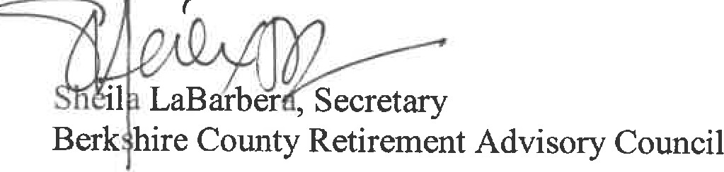

www..ie.rK,!fiire.re.ti.rement.eom

